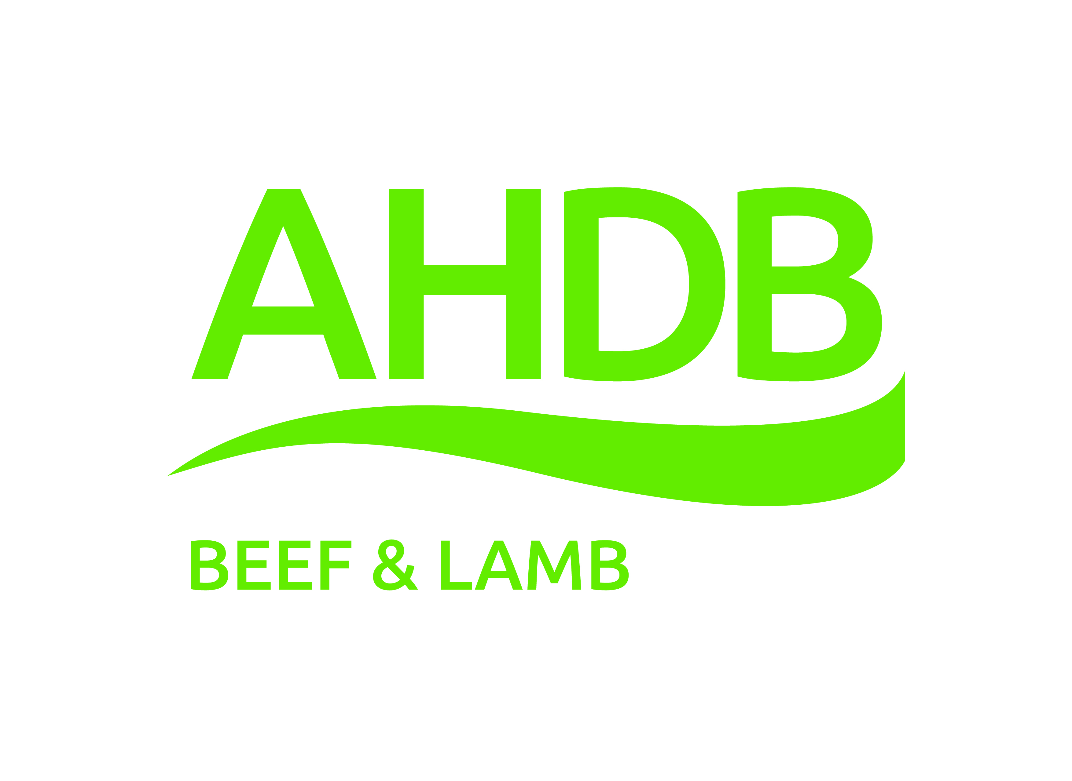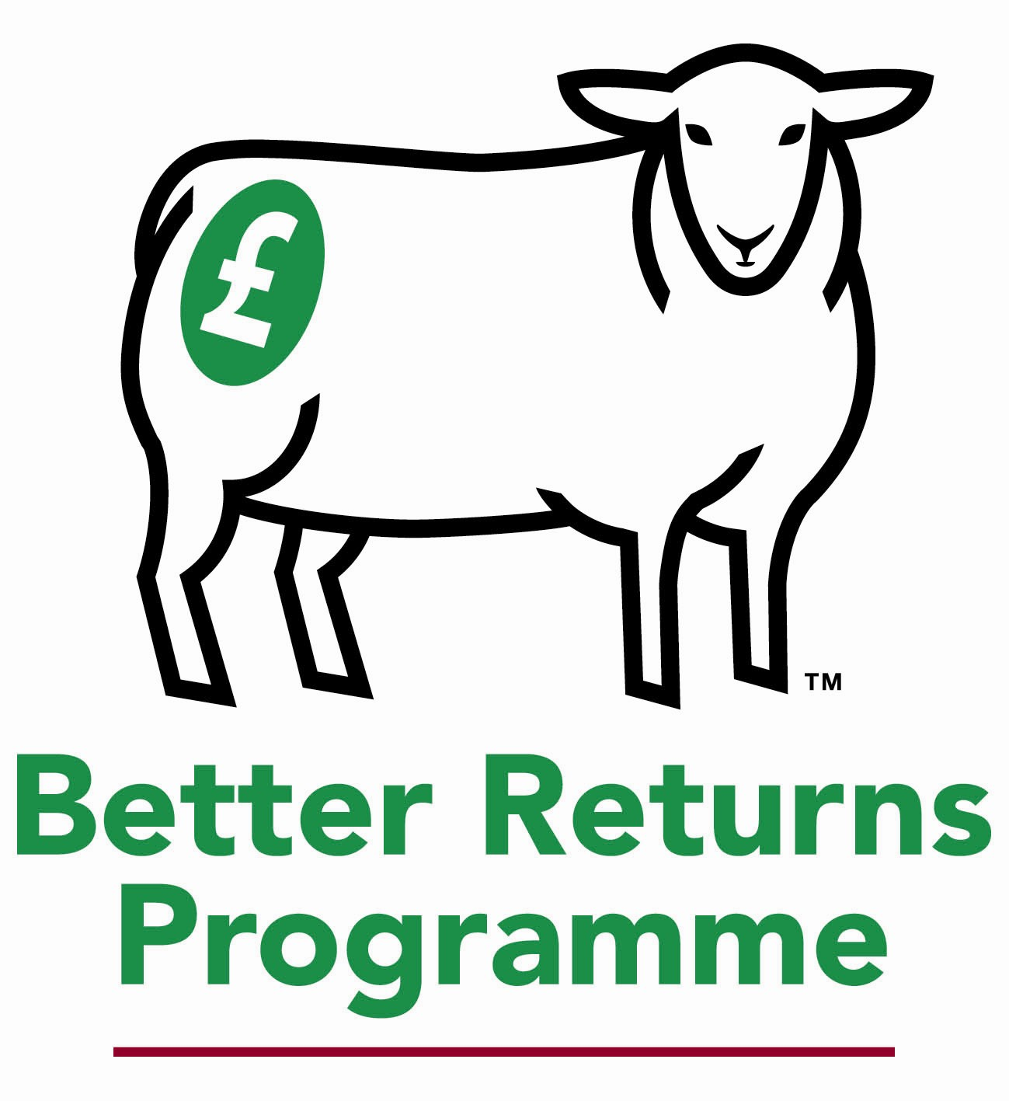
Sheep Breeding and Grassland Management

Weir Park Farm, Christow, Exeter, EX6 7PB
With kind permission of Peter Baber

Thursday August 4th 2016 2.00pm – 4.30pm

Join AHDB Beef & Lamb for this event to explain how combining the right genetics and grassland management can enhance the productivity of sheep production systems. The meeting will take place at Weir Park Farm, which is home to three high index flocks of Suffolk, Texel and Exlana (wool shedding) sheep all of which have been performance tested on a strictly forage based diet.

Steve will talk about developments within terminal sire breeding over the last 20 years and explain how producers can identify the most profitable animals for their flocks using EBVs and breeding indexes. Steve will also talk about maternal breeding programmes and why EBVs are vital in selecting rams to enhance the milking ability and prolificacy of the modern ewe flock.

Bill will talk about optimising forage output through the adoption of different grazing strategies, knowledge of different forage species and the enhancement of both soil fertility and structure.

Programme

2.00pm Arrival and registration with tea and coffee
2.15pm Speaker introductions – Stephen West, AHDB
2.20pm Introduction to Weir Park Farm and the animals bred here – Peter Baber
2.40pm Using EBVs to select the most profitable rams for your flock – Stephen West, AHDB
3.10pm Farm Walk and discussion on grassland management – Bill Reilly, AHDB

4.20pm End with questions & answers

To register your FREE place ring the AHDB Beef & Lamb events office on 01904 771211 or email brp.events@ahdb.org.uk

