2017 Exlana Ram Sale
The 2017 Exlana ram sale will be on Wed. August 9th and we expect to have about 60 rams with exceptional genetics that are the result of many years of ongoing recording and harsh selection. All animals are of course presented in their ‘’working clothes’’ straight from the field –we don’t disguise or ‘’pretty up’’ sheep with artificial colouring or trimming---SIG has a hard-earned reputation for producing sheep that go away and do what it says on the tin.
All Exlana sheep are fully recorded with Signet Breeding Services, and the catalogue provides full details – further information or help with the figures can be found from the Signet website http://www.signetfbc.co.uk/sheepbreeder/technical-information-sheep/esti... or by speaking to one of the Exlana team. SIG has been an industry leader in breeding for worm resistance, working in conjunction with Roslin Institute, Sainsburys and Bristol University to research and identify the Exlana’s genetic resistance to internal parasites. Parasite resistance is increasingly being recognised as a prime economic trait in lamb production, please feel free to speak to team members for details of this work.
Catalogue available from tim@sig.uk.com Rams offered for sale on the day are either from MV accredited flocks or have passed at least one MV blood test. SIG flocks are also disease screened for CLA & OJD
For those of you who haven’t been to one of our sales before the sale procedure is a little different from a regular auction. We use the BLUP data and other records to grade rams, they are then grouped for sale according to price. Potential buyers mark their favoured ram on a card and hold this up when the ram goes into the ring. If there’s only one bidder, then they get the ram. If there are two or more bidders they can decide to progress a regular bidding system or put names in a hat. This system ensures that customers know what their budget is in advance
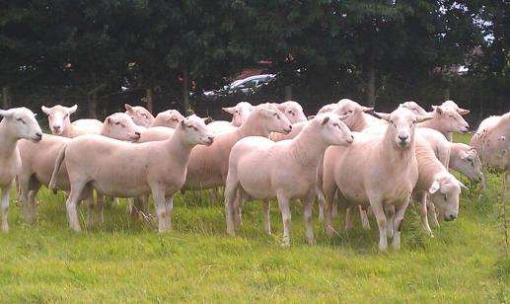
We will also have a representative from ABP to explain their new ‘’ALPHA Ram’’ premium lamb scheme to which SIG is proud to be a supplier
The day begins at;
10.00 am Doors Open and registration.
11.00 am Speakers
12.00 noon Pint and a Pasty lunch
1.00 pm Sale

Rams will be penned from 10 am for inspection and we will be on hand if you need any help or further information. The usual bio-security measures will be in place so please come with a clean vehicle. Please contact us if you have any transport enquiries. The Exlana team look forward to seeing you for what promises to be an interesting day.

